**PIZZA SALES SQL QUERIES**

1. **KPIs**
2. **Total Revenue**

Logic: Sum the sales column from the dataset

Query:

Output:

1. **Average Order Value**

Logic: Divide total revenue by count of order id(distinct)

Query:

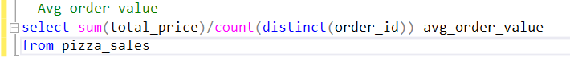

Output:

1. **Total Pizzas sold**

Logic: Sum quantity column

Query:

Output:

1. **Total Orders**

Logic: Sum Order_id from the dataset

Query:

Output:

1. **Average price per order**

Logic: Use aggregate function(sum) on quantity by order counts.

Query:



Output:

1. **Visualizations**
2. **Hourly trend of total orders**

Logic: Use datepart function, use hour and sum quantity

Query:

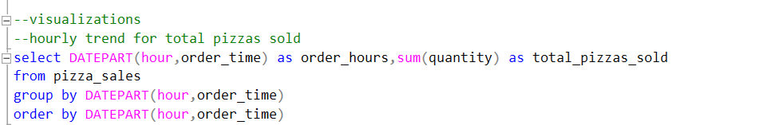

Output:

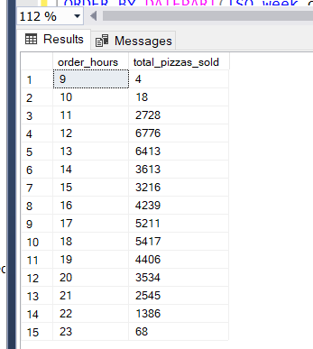

Insights: There are two peak points where the orders rise.

1. **Weekly trend of total_orders**

Logic: Use datepart function, use ISO_week and sum orders

Query:

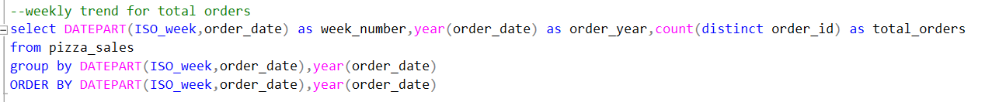

Output:

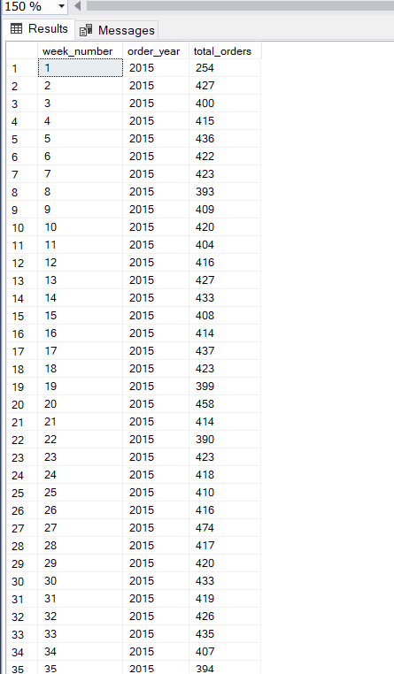

1. **Percentage of sales by category**

Logic: use nested query. Select sales w.r.t category by total price

Query:

Output:

Note: PCT is percentage of category total.